**Travel to School.**

Parking at our school is usually very busy. You can help us by not parking on the Zigzags at the front and back of the school. You can also help by parking further away from the school and walking the rest of the way.

**This is called Park-n-Stride.**

**“Travel”** is a key action point for the Eco team this year. We will be meeting regularly to complete a “Travel Plan” asking for your opinions and ideas so that we can put them into action.

C:\Users\km8119755\AppData\Local\Microsoft\Windows\Temporary Internet Files\Content.IE5\AVVUN2PP\MC900357815[1].wmf

Growing Food in Thorntree

We’ve made a good start to our “**Food and the Environment”** action plan. We recently harvested a bumper crop of potatoes for the kitchen to use and each class will be growing indoor herbs during the winter months. Look on our website for photos.



**Class Eco Representatives 2014-15**

**Jacob Knight Lily Rose McCreadie Chloe Dewar Katie Cross Rachael Campbell Abby Martin Liam Waters James McGhee Ben Phillips Greg McCue Sam Little Lucy Courtney Lee Close Mia Carenduff Lucy Duggan Marc Rodger Mondi Newsome Amy McMillan Rory Goodwin Ellie Lochrane Zoe Murdoch**



**Thorntree Primary**

**Eco News**

**Edition 7 Jan’15**

Hello! Welcome to our Eco Newsletter. Over the past few weeks each class has been nominating and voting for their class Eco Reps. The new reps have all met each other and shared their ideas. We are looking forward to another busy year! The outgoing team did a great job last year and we are very proud of their efforts in helping us achieve our 3rd Green Flag.

Remember to look on the website for more information and pictures of all of our activities. [www.thorntree-pri.glasgow.sch.uk](http://www.thorntree-pri.glasgow.sch.uk)

Eco Week – Monday 18th May

* We will be celebrating the start of Eco Week on Monday afternoon with a performance from Hop Scotch Theatre Company called What a Load of Rubbish. Money that we raise from our Rag Bag appeals help to pay for these fun events.
* Events will be organised for pupils throughout the week.
* On Thursday we will celebrate our love of nature and the environment by hosting Flowery Thursday. This is a non-uniform day and pupils can wear colourful and flowery clothes.



We raised enough money last year to “twin” our toilets with a toilet block in Uganda. The money we raise helps to provide good sanitation and clean water for the Rubaya village in the Kabale District of Uganda. Thank you!

Red Nose Day

Friday 13th March

We will be selling Red Noses from Friday 6th March. Noses cost **£1**

Earth Hour 2015

We have signed up to support WWF’s Earth Hour Campaign on

Saturday 28th March 2015.

“*…a time to think about what we can do every day to help create a brighter future, and a brilliant reminder that together we have the power to make change happen. “ (WWF website)*

**Switch off your lights for one hour at 8.30pm on 28th March**

**Don’t park on the ZIG-ZAGs**

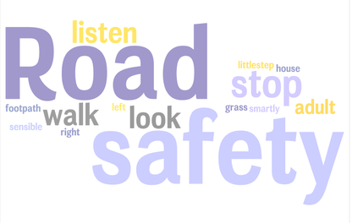



You can bring clothes and textiles into school at any time

**In Thorntree we recycle –**

* Ink Cartridges
* Clothes and Textiles
* Mobile phones
* Paper
* Plastic bottles

**Remember that, on average, the school receives £80 each time we have a Rag Bag collection. A big thank you to everyone who has donated clothes and textiles! We recently collected 229kg of clothing and textiles……thank you!**

Reducing Waste in Thorntree

Here are some suggestions they came up with to reduce lunchtime waste.

* Use a plastic tub with a lid for sandwiches.
* Use a re-usable sandwich wrapper
* Use a re-useable juice bottle.

Let a member of the Eco team know if you are making some changes to your packed lunch. We’ll put your name in the monthly Eco draw for a chance to win a prize.

**…NEWS UPDATE…. NEWS UPDATE….NEWS UPDATE..**

The Eco Team are now selling **“The Wrapper.”** This is a reusable sandwich wrapper that reduces litter and can save you money. They cost £5 each, (50p) goes to school fund. See Mrs MacDonald if you’d like to buy one.

**Let’s reduce the lunchtime waste!** [www.re-wrap-it.co.uk](http://www.re-wrap-it.co.uk)

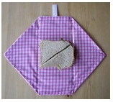

**Let’s keep Thorntree and our local community LITTER FREE!**

**PUT YOUR LITTER IN THE BIN!**

